\. 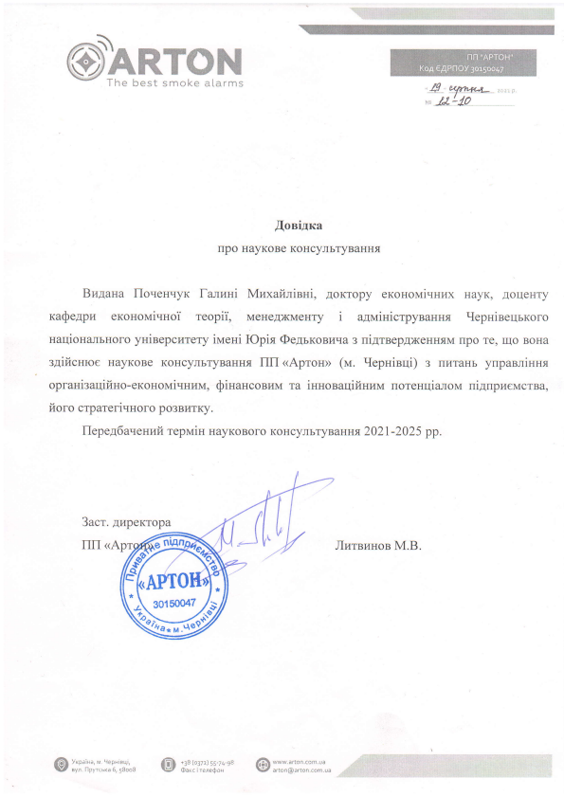

@' WKffi,W .I9 Xprt-t\* , ,, /J40

Aoeitra

npo HayKoBe KoHcynbTyBaHHt

Bul.aua lloveuuyx fanr,rui Muxafininni, AoKropy er<oHorMi.{Hrax HayK, AoqeHTy r<a$e4pz erouolriquoi reopii, MeHeAXMeHry i aavrinicrpynannx gepuineqbKoro naqioualbHoro yninepcHrery irraeni lOpia @e4rr<onL.rra3 ni4rnepAxreHHrM rrpo re, rqo BoHa s4ificuroe HayKoBe KoHcynbryBaHHr lIlI <Aprou> (u. gepnieqi) a rr{raHb ynpanninnr opraHi:aqifiHo-erouol,ti.IHnN,r, SiuancoBr.rM Ta iuHoearlifiHr4M rroreHrlialonr ni4upuenrcrBa, fioro crparerivHoro po3BzrKy.

flepe46au esuir repuin HayKoBoro KoHcynbryBaHHr 202 I -202 5 pp .

3acr.

nn( Jlurnunoe M.B.

.4\ tev 'vv' " w/ P

APTO

30150047

+38 (o3rz) 55-7a-98 $asr i rereScu

r i r',i :l .al